**BI PROJECT DOCUMENTATION**

[Link to original template](https://docs.google.com/document/d/1Ay1VaAjd9JzQJ5JnkPHZLvtDRNAWrc5RYCPo1bvxgBU/edit?usp=sharing) *(*[*link to the Industry Classification Benchmark*](https://en.wikipedia.org/wiki/Industry_Classification_Benchmark)*)*

| **Student ID: *134985*** |  |
| --- | --- |
| **Full name: *Ibrahim Mohamed*** |  |
| **Industry:**  ***20101025 Health Care***  **Sector** |  |
| **Health Care Providers** |  |
| **Subsector:**  ***Health Care Services*** |  |

# Abstract

*Lung cancer is a significant global health concern, accounting for a substantial number of cancer-related deaths each year. In this abstract project, we propose a comprehensive approach to tackle the challenges associated with lung cancer detection, diagnosis, and treatment. Our research focuses on utilizing advanced machine learning techniques to develop a robust and accurate computer-aided diagnosis system for early detection of lung cancer. By analyzing medical imaging data, such as CT scans and X-rays, This project aims to identify subtle patterns and anomalies that may indicate the presence of lung cancer. Additionally, we plan to investigate novel biomarkers and genetic signatures associated with lung cancer, employing cutting-edge genomic technologies. The findings from this project have the potential to revolutionize lung cancer management, leading to earlier detection, personalized treatment strategies, and improved patient outcomes.*

# Section 1: Independent and Dependent Variables

1. **What is the title of your IS Project 2?**

*Please refer to the following explanation of variables in research:* [*https://youtu.be/MnfRdTCUIsc*](https://youtu.be/MnfRdTCUIsc)

| **Title of the project** |  |
| --- | --- |
| **Dependent variable (target/outcome) in the project**  *(Specify* ***only one*** *dependent variable)* | Lung Cancer |
| **Independent variable(s) (predictors) in the project**  *(this is in the form of the actual system that will be developed, e.g. an inventory system (independent variable) will affect stock taking (dependent variable))* | An system to detect anxiety and provide recommendations and affect the student’s mental health |
| **Hypothesis** *(Provide a proposed statement of how the independent variables (modules of the system) affect the dependent variable)* | The dependent variable of the presence or absence of lung cancer is strongly affected by the independent variables of smoking status, exposure to environmental contaminants, family history of lung cancer, and genetic susceptibility. Individuals who are current or former smokers, have a history of environmental pollution exposure, have a family history of lung cancer, or have certain genetic mutations associated with lung cancer are more likely to be diagnosed with lung cancer than those who do not have these risk factors. |
| **Research Question** *(Formulate a “How?” question using the hypothesis. Quote: “you will never get the right answer without asking the right question”)* | How may the use of Machine learning algorithms may assist in early detection of Lung Cancer? |

# Section 2: Problem Statement

1. **Answer the following 5 questions to clearly (by being brief and straight to the point) specify the Problem Statement based on your IS Project 2**

| **What is the problem?** | Lung Cancer |
| --- | --- |
| **Where is the problem being experienced?** | Lungs,Patients’ health |
| **Since when has it been a problem?** |  |
| **Why is the problem still being experienced?** | Smoking Addictions,Environmental issues, |
| **Who is affected by the problem?** | Smokers, people exposed to soot,passive smokers |

| **Based on the above answers, what type of AI-driven problem is it?**  *Options: classification problem, regression problem, association problem, or clustering problem.* ***Note:*** *what we have focused on in the BI Option is classification and regression problems.* | Classification |
| --- | --- |

# Section 3: Proposed Solution (Data-Driven Solution in the form of a Data Product)

1. **Describe the proposed data-driven solution by answering the following questions**

| **Which algorithms (list more than 1) can be used to train the model based on whether it is solving a classification, regression, association, or clustering problem?**  *E.g., linear regression, logistic regression, Linear Discriminant Analysis (LDA), decision tree, Naive Bayes, k-Nearest Neighbours (KNN), Learning Vector Quantization (LVQ), Support Vector Machines (SVM), etc.* | K - Nearest Neighbours , Support Vector Machines |
| --- | --- |
| **What does the business require from the data product?**  *For business-facing analytics* | How many patients are affected by Lung cancer? |
| **What reports do the customers of the business require from the data product?**  *For customer-facing analytics* | Patients can check Progress on their Lung Cancer? |
| **What will the model be used to predict (Identify only one variable and be specific. Specify the possible classes if it is a classification problem.)?**  *The target/outcome/dependent variable*  *It should be related to the project’s dependent variable.* | The level of chronic lung disease |
| **What variables does the model require to make the prediction (list multiple variables and be specific)?**  *The predictors/independent variables* | Prescence of Yellow Fingers, Fatigue,Age,Allergy,Wheezing,Chronic Disease,Smoker,Anxiety,Chest Pain,Drink Alcohol,Peer Pressure, |
| **Where are you going to get a sample dataset?**  *Provide the link to a specific dataset that has similar variables. Possible sources of datasets include:*   1. *University of California (UC) Irvine:* [*https://archive.ics.uci.edu/datasets*](https://archive.ics.uci.edu/datasets) 2. *Kaggle:* [*https://www.kaggle.com/datasets*](https://www.kaggle.com/datasets) 3. *Data Science Dojo:* [*https://datasciencedojo.com/blog/datasets-data-science-skills/*](https://datasciencedojo.com/blog/datasets-data-science-skills/) *or* [*https://code.datasciencedojo.com/datasciencedojo/datasets*](https://code.datasciencedojo.com/datasciencedojo/datasets) 4. *Kenya Open Data:* [*https://kenya.opendataforafrica.org/data/#menu=topic*](https://kenya.opendataforafrica.org/data/#menu=topic) 5. *openAFRICA:* [*https://africaopendata.org/*](https://africaopendata.org/) 6. *Datahub.io:* [*https://datahub.io/collections*](https://datahub.io/collections) 7. *Data.world:* [*https://data.world/*](https://data.world/) 8. *Google Data Search:* [*https://datasetsearch.research.google.com/*](https://datasetsearch.research.google.com/) 9. *Google Public Data Explorer:* [*https://www.google.com/publicdata/directory*](https://www.google.com/publicdata/directory) 10. *Data.gov:* [*https://www.data.gov/*](https://www.data.gov/) 11. *Global Health Observatory Data Repository:* [*https://apps.who.int/gho/data/node.home*](https://apps.who.int/gho/data/node.home) 12. *UNICEF Data:* [*https://data.unicef.org/*](https://data.unicef.org/) 13. *Earth Data:* [*https://earthdata.nasa.gov/*](https://earthdata.nasa.gov/) 14. *CERN Open Data Portal:* [*http://opendata.cern.ch/*](http://opendata.cern.ch/) 15. *FBI Crime Data Portal:* [*https://crime-data-explorer.fr.cloud.gov/*](https://crime-data-explorer.fr.cloud.gov/) 16. *New York City Taxi Trip Data:* [*https://www1.nyc.gov/site/tlc/about/tlc-trip-record-data.page*](https://www1.nyc.gov/site/tlc/about/tlc-trip-record-data.page) 17. *Our World in Data:* [*https://ourworldindata.org/*](https://ourworldindata.org/) 18. *World Bank Open Data:* [*https://data.worldbank.org/*](https://data.worldbank.org/) 19. *World Poverty:* [*https://worldpoverty.io/map*](https://worldpoverty.io/map) 20. *Worldometers:* [*https://www.worldometers.info/*](https://www.worldometers.info/) 21. *European Data:* [*https://data.europa.eu/en*](https://data.europa.eu/en) 22. *Livestock Data for Decisions (LD4D):* [*https://www.livestockdata.org/type/datasets*](https://www.livestockdata.org/type/datasets)   *etc.* | <https://www.kaggle.com/datasets/thedevastator/cancer-patients-and-air-pollution-a-new-link>  <https://www.kaggle.com/datasets/mysarahmadbhat/lung-cancer> |
| **What can’t the user (both the employees in the business and the customers of the business) do now that they will be able to do in future using the data products (business-facing analytics dashboard, customer-facing analytics dashboard, and the prediction model)?** | Can predict the likelihood a patient is sick with lung cancer |

# Section 4: Industry, Sector, and Subsector

1. **Can the problem statement involve a business? If yes, in which industry, sector, and subsector would the business operate in according to the** [**Industry Classification Benchmark**](https://en.wikipedia.org/wiki/Industry_Classification_Benchmark)**?**

| **Industry** | **Sector** | **Sub-Sector** |
| --- | --- | --- |
| ***20101025 Health Care*** | **Health Care Providers** | ***Health Care Services*** |

# Section 5: Strategic Objectives based on Industry Standards/Expectations

1. **Using the industry's standards/expectations as a guideline, identify one possible strategic objectives for the business in each of the 4 perspectives of Kaplan and Norton's balanced scorecard, i.e., the Innovation and Learning Perspective, the Internal Business Processes Perspective, the Customer Perspective, and lastly, the Financial Perspective.**

| **Kaplan & Norton’s  Balanced Scorecard Perspective** | **Strategic Objective** |
| --- | --- |
| **Innovation and Learning Perspective** | SO1:Develop and implement a comprehensive training program for employees to enhance their skills and knowledge in using AI based tools |
| **Internal Business Processes Perspective** | SO2:Improve operational efficiency and quality of healthcare delivery |
| **Customer Perspective** | SO3:Gather and analyse patient feedback regularly to identify areas for improvement and address any concerns promptly. |
| **Financial Perspective** | SO4:Implement cost-control measures to reduce operational expenses while maintaining quality care |

# Section 6: Leading and Lagging Indicators

1. **Identify leading and lagging indicators that can be associated with each strategic objective. Give each KPI a unique identifier.**

| **Strategic Objective** | **Leading Indicator** | **Lagging Indicator** |
| --- | --- | --- |
| **SO1** | KPI1a: Percentage of employees trained in AI-based tools for lung classification | KPI1b: Time saved in lung classification process after implementing AI-based tools |
| **SO2** | KPI2a:Average waiting time for patients | KPI2b:Patient satisfaction rating on quality of care |
| **SO3** | KPI3a: Number of patient feedback submissions | KPI3b:Improvement in patient satisfaction scores over time |
| **SO4** | KPI4a: Average length of stay for patients | KPI4b:Revenue per patient encounter |

# Section 7: Presentation Category for each Indicator

1. **Classify each KPI as raw numbers, progress, or change, with a preference for the KPIs presented in the form of a change indicator**

| **Leading Indicator** | **Presentation Category** (raw numbers, progress, or change) | **Lagging Indicator** | **Presentation Category** (raw numbers, progress, or change) |
| --- | --- | --- | --- |
| KPI1a | Progress Indicator | KPI1b | Change Indicator |
| KPI2a | Change Indicator | KPI2b | Raw Number Indicator |
| KPI3a | Progress Indicator | KPI3b | Change Indicator |
| KPI4a | Change Indicator | KPI4b | Raw Number indicator |

# Section 8: Presentation Attribute for each Indicator

1. **Describe the 5 attributes (measure, target, source, responsible user, and frequency) for each KPI**

**For the source of the data:** *In addition to specifying the actual source (the OLTP relational database), also specify the ethical considerations that need to be made as the data is being extracted from the source. Refer to the “*[*The Kenya Data Protection Act No. 24 of 2019*](http://kenyalaw.org:8181/exist/rest/db/kenyalex/Kenya/Legislation/English/Acts%20and%20Regulations/D/Data%20Protection%20Act%20-%20No.%2024%20of%202019/docs/DataProtectionAct24of2019.pdf)*”.*

## KPI1a: Percentage of employees trained in AI-based tools for lung classification-Leading

| **Presentation Attribute** | **Description** |
| --- | --- |
| **Measure** | Percentage(%) |
| **Target** | Achieve a minimum of 80% employee training in AI-based tools for lung classification. |
| **Source** | Human Resources Training Records (OLTP relational database) |
| **Responsible User** | Human Resources Department |
| **Frequency** | Quarterly |

## KPI1b:Time saved in lung classification process after implementing AI-based tools-Lagging

| **Presentation Attribute** | **Description** |
| --- | --- |
| **Measure** | Time saved (in minutes or hours) |
| **Target** | Achieve a 20% reduction in the average time spent on lung classification after implementing AI-based tools. |
| **Source** | : Electronic Medical Records (EMR) or Workflow Management System (OLTP relational database) |
| **Responsible User** | Operations or Clinical Efficiency Department |
| **Frequency** | Monthly |

## KPI2a: Average waiting time for patients- Leading

| **Presentation Attribute** | **Description** |
| --- | --- |
| **Measure** | Time (in minutes) |
| **Target** | Maintain an average waiting time of less than 30 minutes for patients. |
| **Source** | Appointment and Queue Management System (OLTP relational database) |
| **Responsible User** | Operations or Patient Services Department |
| **Frequency** | Daily |

## KPI2b: Patient satisfaction rating on quality of care-Lagging

| **Presentation Attribute** | **Description** |
| --- | --- |
| **Measure** | Rating scale (e.g., 1-5) |
| **Target** | Achieve a patient satisfaction rating of 4 or higher on a 5-point scale. |
| **Source** | Patient Satisfaction Surveys or Feedback Management System (OLTP relational database) |
| **Responsible User** | Quality Assurance or Patient Experience Department |
| **Frequency** | Quarterly |

## KPI3a:Number of patient feedback submissions- Leading

| **Presentation Attribute** | **Description** |
| --- | --- |
| **Measure** | Count |
| **Target** | Increase the number of patient feedback submissions by 10% compared to the previous quarter. |
| **Source** | Patient Satisfaction Surveys or Feedback Management System (OLTP relational database) |
| **Responsible User** | Quality Assurance or Patient Experience Department |
| **Frequency** | Monthly |

## KPI3b: Improvement in patient satisfaction scores over time-Lagging

| **Presentation Attribute** | **Description** |
| --- | --- |
| **Measure** | Percentage improvement (%) |
| **Target** | Achieve a 5% increase in patient satisfaction scores compared to the baseline measurement. |
| **Source** | Patient Satisfaction Surveys or Feedback Management System (OLTP relational database) |
| **Responsible User** | Quality Assurance or Patient Experience Department |
| **Frequency** | Quarterly |

## KPI4a: Average length of stay for patients-Leading

| **Presentation Attribute** | **Description** |
| --- | --- |
| **Measure** | Time (in days) |
| **Target** | Reduce the average length of stay for patients by 10% compared to the previous year. |
| **Source** | Electronic Medical Records (EMR) or Hospital Information System (OLTP relational database) |
| **Responsible User** | Clinical Efficiency or Operations Department |
| **Frequency** | Monthly |

## KPI4b: Revenue per patient encounter-Lagging

| **Presentation Attribute** | **Description** |
| --- | --- |
| **Measure** | Monetary value (currency) |
| **Target** | Increase revenue per patient encounter by 5% compared to the previous quarter. |
| **Source** | Financial Management System or Billing System (OLTP relational database) |
| **Responsible User** | Finance or Revenue Management Department |
| **Frequency** | Quarterly |

# 

# Section 9: Measures and Dimensions

1. **Identify the measures (categorical data) and the dimensions (quantitative data) for the applicable KPIs**

| **Categorical Data (Measures): Nominal, ordinal, or time-series data** *(State the actual category and whether it is nominal, ordinal, or time-series data)* | **Associated KPIs** |
| --- | --- |
| *For example: List of counties in Kenya (nominal data)* | *List of counties is required by KPIs: 1a, 3b, and 4a* |
| Percentage of employees trained in AI-based tools for lung classification(Nominal data) | KPI:1a |
| Patient satisfaction rating on quality of care( Ordinal data) | KPI:2b |
| Improvement in patient satisfaction scores over time(Time-series data) | KPI:3b |
|  |  |

| **Quantitative Data (Dimensions): Interval scale or ratio scale data** | **Associated KPIs** |
| --- | --- |
| Revenue per patient encounter(ratio scale) | KPI:4b |
| Number of patient feedback submissions (Ratio scale data) | KPI: 3a |
| Average length of stay for patients(interval scale data) | KPI: 4a |
| Average waiting time for patients(interval scale) | KPI:2a |
| Time saved per classification process (Ratio scale) | KPI:1b |

# Section 10: Type of Message

1. **Describe the type of message (one message per KPI) that each KPI intends to communicate**

| **KPI** | **Proposed Message Type** *(comparison, distribution, composition, or relationship; refer to this article:* [*https://extremepresentation.typepad.com/blog/2006/09/choosing_a_good.html*](https://extremepresentation.typepad.com/blog/2006/09/choosing_a_good.html) *)* |
| --- | --- |
| KPI1a | *distribution* |
| KPI1b | *comparison* |
| KPI2a | *composition* |
| KPI2b | *relationship* |
| KPI3a | *composition* |
| KPI3b | *distribution* |
| KPI4a | *comparison* |
| KPI4b | *relationship* |

# Section 11: Visualisation Type

1. **Identify visualisations that can be used for each KPI**

| **KPI** | **Proposed Visualisation Type** *(at least 2 types for each KPI)* |
| --- | --- |
| KPI1a |  |
| KPI1b |  |
| KPI2a |  |
| KPI2b |  |
| KPI3a |  |
| KPI3b |  |
| KPI4a |  |
| KPI4b |  |

# Section 12: Business-Facing Analytics Dashboard Layout

1. **Use a mockup to present the proposed position of each visualisation on a dashboard for the employees of the business**

Proposed (not mandatory) applications that can be used to design the mockup of the dashboard include: <https://clickup.com/features/dashboards>

**Note:** This is a mockup of the dashboard. A mockup is a visual design of the final version of a User Interface, not the final version.

**Also Note:** The dashboard must have all the 4 Kaplan & Norton’s Balanced Scorecard Perspectives

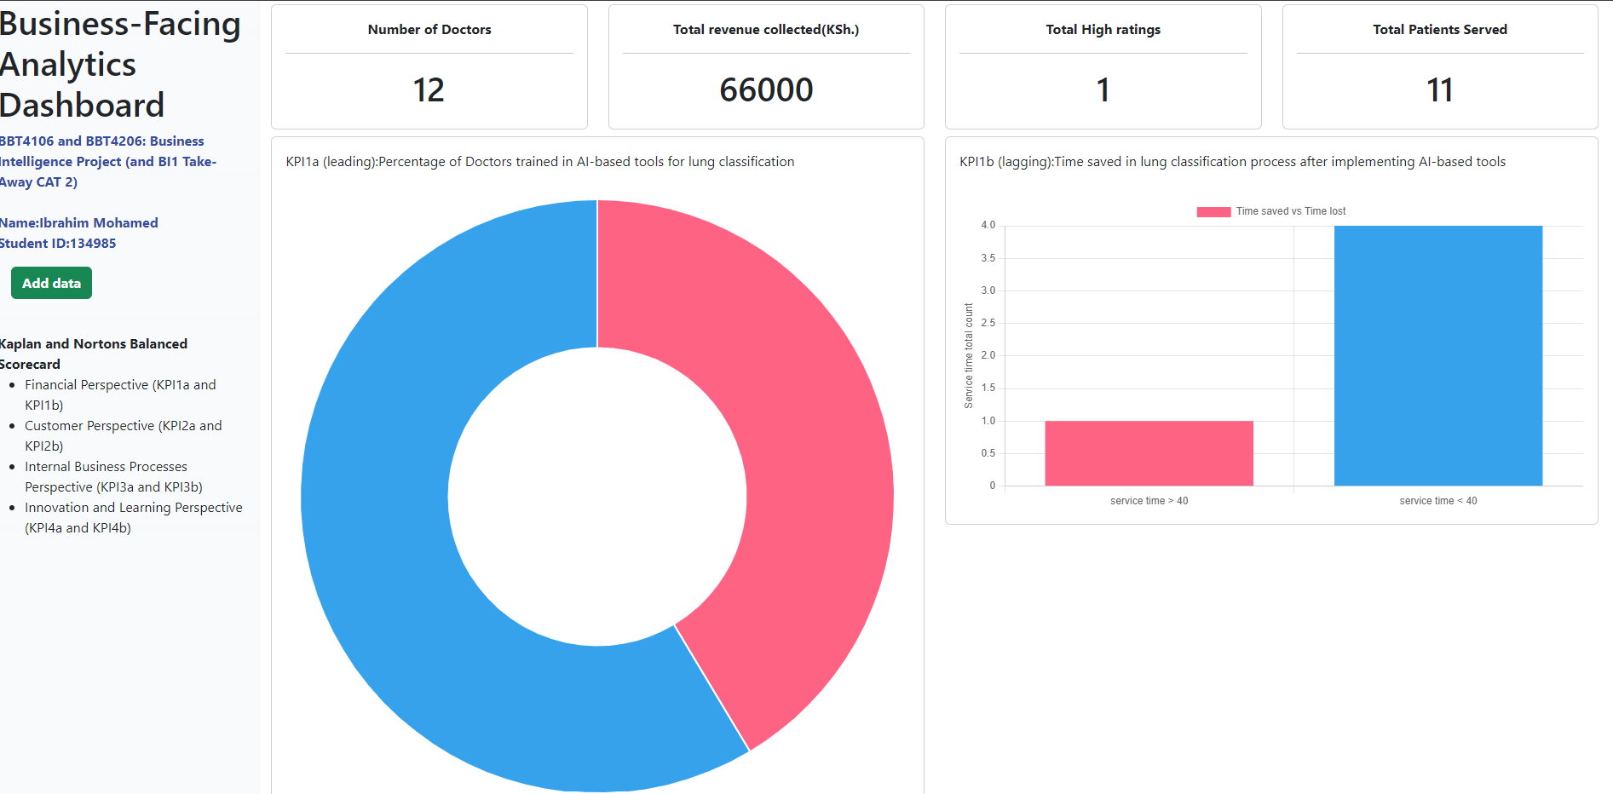

# Section 13: Customer-Facing Analytics Dashboard Layout

1. **Use a mockup to present the proposed position of each visualisation on a dashboard for the customers of the business**

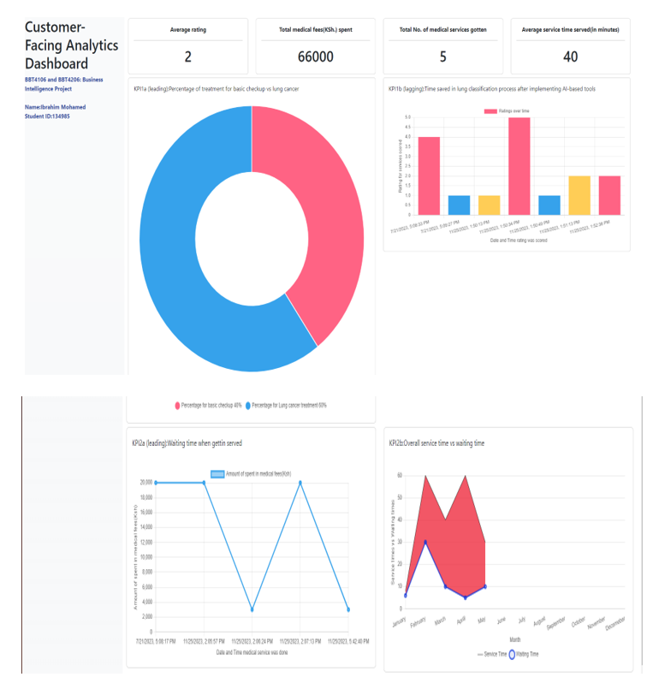

# Section 14: DataOps Strategy

1. **Describe the DataOps strategy that will be applied to deliver the solution**

| **Describe how functional testing, unit testing, integration testing, and API reliability testing will be carried out on the data products** | Identify key functionalities, use cases, and scenarios that the data products should support, such as data visualization, report generation and predictive analytics for functional testing.  Focus on testing specific parts of the system, such as a data transformation script, an algorithm for predictive analytics, or a module for data cleaning.  Define scenarios that involve interactions between various components, such as ETL (Extract, Transform, Load) processes, database connections and API integrations. |
| --- | --- |
| **Describe how the prediction models will be validated** | Methods such as cross-validation and grid search will be employed to refine the hyperparameters of the model in order to maximize its performance on the validation set.  Validation Metrics such as F1 score to check validation |
| **Specify all the Minimum Viable Products that can be delivered to form the whole data product (to form 2 dashboards and 1 model)** | -A machine learning model for predicting lung cancer ,  -Data collection and pre -processing module.  -Dashboards for insights |
| **Specify when each Minimum Viable Product will be delivered (the exact date according to the IS Project 2 Gantt chart and according to the BI semester dates)** | -28th November 2023 |

# Section 15: Link to Dashboard

1. **Link to the 2 dashboards hosted on** [**https://www.shinyapps.io/**](https://www.shinyapps.io/)

**Link:**

<https://github.com/ibz11/BusinessIntelligence_dashboard.git>

# Section 16: Link to Model Training Markdown

1. **Specify the link to the markdown hosted on** [**https://rpubs.com/**](https://rpubs.com/) **that displays how the model was trained**

**Link:**

<https://github.com/ibz11/BI2-134985-Lungcancer.git>

# Section 17: BI Implementation Strategy

Many businesses fail by attempting to adopt new technologies too fast across the entire business without a proper plan. A proper plan should outline how the technology will be used to solve a clearly defined problem.

1. **Propose a BI implementation Strategy that the business should follow to make the project a success:**
   1. **Data Quality and Validation**
      1. ***Data governance:***

Ensure that data is validated and verified at the point of entry into the system. Implement automated checks to flag inconsistencies or inaccuracies.

* + 1. ***Data auditability:*** *Implement version control and timestamp mechanisms to track changes made to data elements, enabling the ability to trace alterations and revert to previous versions if necessary.*
    2. ***Data lineage:*** *Document and maintain a clear record of data lineage, tracking the flow of data from its original sources through various transformations and calculations to its final destination.*
  1. **Model Lifecycle (based on MLOps)**

*In order to effectively train and validate machine learning models, it is imperative to identify and collect pertinent data sources. These sources serve as the foundation for acquiring the necessary information to enhance the performance and accuracy of the models.*

*In order to facilitate the analysis of data, it is imperative to establish and execute data pipelines and integration processes. These mechanisms serve the purpose of gathering, purifying, and preparing the data for subsequent analysis.*

*Conducting exploratory data analysis (EDA) is imperative in order to acquire a comprehensive understanding of the data at hand. This process involves delving into the dataset, meticulously examining its various attributes, and discerning potential features that hold the potential to significantly contribute to the development of a robust model.*

*In order to effectively capture the inherent patterns within the data, it is imperative to construct features that exhibit both high importance and relevance.*

*The process of constructing and refining a model, as well as the subsequent training of said model, is a crucial aspect in the realm of academic research and data analysis. This stage involves the systematic development of a model, which serves as a representation.The selection of appropriate machine learning algorithms should be contingent upon the specific business problem at hand and the inherent characteristics of the available data.*

*The process involves training several models, conducting hyperparameter tuning, and performing cross-validation to identify the most optimal models in terms of performance. Throughout this process, it is crucial to monitor for any signs of overfitting.In the realm of data science, the process of model evaluation and validation holds significant importance. It serves as a critical step in assessing the performance and reliability of predictive models. By employing various techniques and metrics, researchers and practitioners can gauge the effectiveness*

*The evaluation of models is conducted by utilising validation datasets, wherein a range of metrics such as accuracy, precision, recall, and others are assessed. The primary objective is to ascertain whether the models fulfil the predetermined success criteria.The utilisation of business intelligence tools is recommended in order to effectively visualise and communicate the metrics pertaining to model performance to relevant stakeholders.*

*The subject of interest pertains to the deployment and integration of models with business intelligence (BI) tools.The trained model should be deployed in a production environment, enabling its accessibility through APIs or integration within business intelligence dashboards. This will facilitate real-time predictions and analysis.*

* 1. **Data Warehousing Approach**

*Ralph Kimball's Dimensional Modelling Approach is a well-known data warehousing and business intelligence approach. It focuses on developing data models, especially the star and snowflake schemas, that are optimised for querying and analysis. A core fact table is surrounded by denormalized dimension tables in the star schema, which simplifies queries. The snowflake schema, on the other hand, expands dimensions into normalised structures. Fact tables store business metrics and are linked to dimension tables, which store descriptive qualities. Kimball emphasises conformed dimensions for consistency across various tables, Slowly Changing Dimensions (SCDs) to manage changing dimension characteristics, and aggregated fact tables to improve query efficiency. This technique offers a straightforward foundation for data organisation that is extensively used in OLAP systems due to its efficacy in supporting reporting and analytics requirements.*

* 1. **Data Pipelines**

*Batch processing includes handling data at predetermined intervals, making it appropriate for situations when instantaneous processing is not required. It is critical in a wide range of businesses for large-scale data management, analytics, and reporting. Data is gathered over time and processed in batches, making it ideal for bulk data analysis, providing periodic reports, and handling large datasets or difficult calculations during off-peak hours. While it saves resources and facilitates in the management of many data types such as structured, unstructured, legacy, and IoT data, it lacks real-time insights. Ethical issues are critical, with a focus on data protection, accuracy, openness, fairness, and gaining permission for sensitive data processing. Maintaining trust and integrity in data handling procedures requires ensuring compliance with legislation such as GDPR and CCPA, as well as correcting biases.*

* 1. **The Data Warehouse Schema**

*Design a star schema or a snowflake schema for a Multidimensional OLAP architecture. This is informed by the measures and dimensions identified earlier in this project.*

# Section 18: Essay

1. **Business Intelligence is not solved with technology only. You need organisational buy-in. Write a 1,500-word essay to discuss a business-first, technology-second perspective in relation to the BI project**

The implementation of Business Intelligence (BI) initiatives in the healthcare sector frequently emphasizes technological advancements. However, their success is not solely reliant on technical expertise, but also on the alignment and support within the organization. The present essay explores the crucial significance of embracing a business-oriented approach that prioritizes the utilization of technology, specifically within the realm of a business intelligence (BI) initiative focused on forecasting lung cancer through the application of K-Nearest Neighbors (KNN) classification.

The integration of business intelligence (BI) within the healthcare industry entails the convergence of data analytics, predictive modeling, and technology in order to extract practical and actionable insights. The primary focus of this endeavor centers on enhancing the processes of decision-making, enhancing the standards of patient care, and optimizing operational efficiencies. The application of K-nearest neighbors (KNN) classification in the prediction of lung cancer exemplifies the incorporation of technological advancements into the field of healthcare, with the aim of facilitating early identification and enhancing prognostic outcomes.

Highlighting a business-centric perspective in the realm of Business Intelligence (BI) underscores the imperative of harmonizing technological progress with overarching organizational goals. In the specific domain of lung cancer prediction, the establishment of well-defined business objectives holds paramount importance. These objectives may encompass the reduction of mortality rates, the enhancement of treatment efficacy, or the optimization of resource allocation within healthcare establishments.

The success of a business intelligence (BI) project, particularly in industries with sensitive domains such as healthcare, is greatly contingent upon obtaining the support and commitment of the organization. Active involvement and support from various stakeholders, including clinicians, administrators, data scientists, and IT professionals, is imperative in order to address this matter effectively. In the absence of their endorsement and unwavering dedication, the project runs the risk of encountering obstacles, facing opposition, or experiencing restricted acceptance.

Firstly ,The utilization of a technology-centric approach, in the absence of a well-defined business strategy and widespread organizational support, gives rise to a multitude of complex challenges.

Secondly ,The absence of relevance can be observed when considering the implementation of advanced algorithms such as K-Nearest Neighbors (KNN) for the purpose of predicting lung cancer. It is plausible that this approach could potentially yield precise outcomes. Nonetheless, the failure to acknowledge the specific requirements of healthcare providers or to align with the objectives of patient care could potentially render the insights inconsequential or inadequately utilized.

Thirdly ,Resistance to Adoption: It is plausible that healthcare professionals may exhibit resistance or fail to acknowledge the predictive model in the event that they experience a sense of detachment from the process or harbor uncertainties regarding its clinical significance. Insufficient engagement or comprehension may give rise to doubt and hinder the execution of a task.

Fourthly, Insufficient Data Integration: The exclusive emphasis on technology may inadvertently disregard the complexities associated with the integration of heterogeneous healthcare data sources. The potential ineffectiveness of the predictive model may arise if one disregards the significance of data quality, privacy concerns, or interoperability issues.

Moreover,the involvement of clinicians, healthcare administrators, and data scientists from the very beginning of a project is of utmost importance in ensuring effective stakeholder engagement. In order to effectively customize the predictive model to meet their individual needs, it is essential to comprehend and acknowledge the requirements, concerns, and perspectives of the individuals involved.

Additionally, Effective Communication: It is crucial to articulate the goals, approach, and potential advantages of the project to stakeholders using language that is accessible and understandable, avoiding technical jargon. It is crucial to emphasize the correlation between the predictive model and its potential to enhance patient outcomes and inform clinical decision-making in order to achieve a thorough comprehension.

The adoption of an iterative development process facilitates the ongoing reception of feedback and the subsequent refinement of the predictive model. Promoting collaboration between data scientists and healthcare professionals is crucial in ensuring the clinical relevance and accuracy of the model.

Lastly,The provision of extensive training and support to healthcare professionals plays a crucial role in facilitating the optimal utilization of the predictive model. The act of addressing concerns, offering guidance, and presenting tangible examples of successful real-world implementations plays a crucial role in facilitating the successful adoption of a particular concept or practice.

In essence, the success of a business intelligence (BI) project centered around the prediction of lung cancer through K-nearest neighbors (KNN) classification is not solely dependent on the technological implementation, but rather relies on its strategic alignment with the objectives of the organization and the support it receives from key stakeholders. Emphasizing a prioritization of business objectives over technological considerations underscores the importance of aligning technological progress with the specific requirements and goals of the healthcare institution. Through the prioritization of stakeholder engagement, clear communication, iterative development, training, and ethical considerations, organizations have the ability to fully harness the potential of business intelligence (BI) projects. This enables them to effectively leverage predictive models, resulting in improved patient outcomes and more informed decision-making within the healthcare industry.